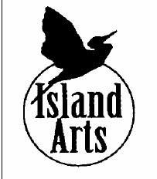
Priscilla Rose Talent Award APPLICATION
DOWNLOAD FILE TO COMPLETE
This application form is for permanent residents of Grand Isle County who wish to pursue individual study in the arts or participate in arts activities. Scholarship funds will be paid direct to the program / instructor. Please answer the following questions on this form and include an additional sheet of paper if necessary.

In addition, please provide a personal letter of support from your instructor(s) and attach the material requested below regarding the program(s) / instructor(s) offering the activity / instruction.
NAME:
NAME OF PARENT OR GUARDIAN:

ADDRESS:
EMAIL: | PHONE:
DATE of BIRTH of APPLICANT:
- Describe the nature of your request. Include a statement indicating a desire for the lessons/program requested.
- Describe your background, interests, or wishes that relate to your chosen artistic discipline.
- Provide information about the cost of the study/program. Include a copy of your acceptance letter and / or letter(s) of recommendation or other program information from the organization and/or the instructor(s).
We ask that all scholarship recipients be willing to share their experience with others. This may take the form of a public presentation, performance, or exhibit, or simply the publication of your name and a photo. Your signature below signifies that you are willing to participate in publicity efforts for Island Arts and that your statements above are true to the best of your knowledge.

Signature of Applicant: |  | Date:
For minors, signature of Parent/Guardian: |  | Date:
Return to: Scholarship Committee, Island Arts, PO Box 108, North Hero, VT 05474
Islandarts.org | info@islandarts.org | 802-372-8889

